PRESS RELEASE
For immediate release
Air Ambulance’s new paramedics share insight as Summer Raffle lifts off!
Great Western Air Ambulance Charity (GWAAC) is proud to launch its Summer Raffle, where the biggest win isn’t just for the lucky ticket holders. Every £1 ticket sold is an investment in the ongoing professional development of GWAAC’s specialist crew—essential for providing the best care possible to people in urgent need of critical care.
GWAAC brings the skills and equipment of a hospital emergency department to the most critically ill and injured in its region and demand for its service is higher than ever. James Leavor and Waldo Zweep are two of GWAAC’s newest recruits, training to be Specialist Paramedics in Critical Care (SPCC). They have gone through a competitive recruitment process and rigorous training to get to where they are now; it takes two years to become a fully trained SPCC.
Trainee SPCC James says, “The hardest part of this job so far is the weight you feel on your shoulders when you arrive at the scene. You see people visibly relax and there’s an expectation that you will know, in seconds, exactly what to do and exactly how to do it. It’s difficult not to feel the pressure of that, but the training and support I’m receiving gives me confidence to do my absolute best for every patient.”
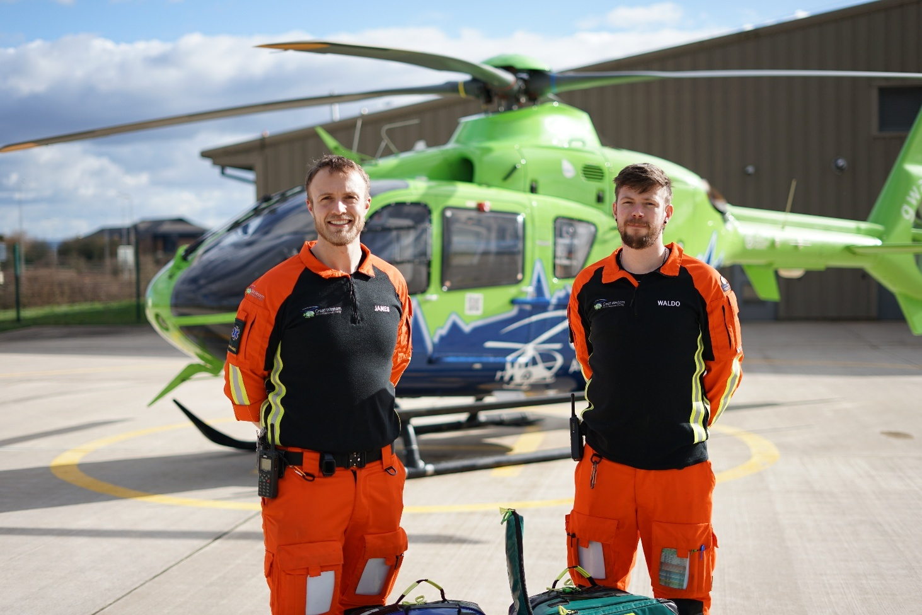

Trainee SPCC Waldo says, ”There is a huge amount of effort from the community that goes into me being able to put on my uniform and come to work in the morning – from buying things in our shops, to making donations, to buying a raffle ticket!”
Emergency medicine doesn’t stay still and the only way for GWAAC’s crew to stay prepared for anything is through regular, ongoing training. With the charity receiving no day-to-day government funding and relying entirely on the local community to keep flying, the Summer Raffle is a fantastic way to get involved and make a difference! Tickets are just £1 each, with a top prize of £2,500 on offer. Tickets can be purchased by visiting raffle.gwaac.com or by visiting any of GWAAC’s 12 charity shops. Your ticket to £2,500 could be their ticket to lifesaving skills.
Players must be 18 years old or over to enter. Entry closing dates are Monday 18 August by post and Monday 25 August online. The raffle draw date is Wednesday 27 August 2025.
About GWAAC
GWAAC provides the critical care and air ambulance service for 2.1 million people across Bristol, Gloucestershire, Bath and North East Somerset, South Gloucestershire, North Somerset, and parts of Wiltshire.
In 2024, GWAAC was called to a record number of incidents. The specialist crew responded to 2,272 people in urgent need of critical care — an increase of around 15% compared to 2023.
And did you know that you’re more likely to see the crew out and about in one of their fully-equipped critical care cars than in the helicopter? In 2024, GWAAC’s crew responded to 77% of call-outs in one of the charity’s critical care cars and 23% in its bright green and blue helicopter.
ENDS
Notes for editors
- GWAAC provides the critical care and air ambulance service for 2.1 million people across Bath and North East Somerset, Bristol, South Gloucestershire, Gloucestershire, North Somerset, and parts of Wiltshire.
- The GWAAC Critical Care Team consists of highly trained and experienced Critical Care Doctors, Advanced Practitioners and Specialist Paramedics in Critical Care, who bring the skill and expertise of a hospital emergency department to the patient.
- 2024 was GWAAC’s busiest year on record with 2,272 people in urgent need requiring immediate critical care. GWAAC’s Critical Care Team is needed by more than six patients a day on average and rushes to treat them by helicopter or critical care car. On average each mission costs around £2,200 to attend.
- The charity needs to raise over £4 million a year to remain operational yet receives no day-to-day funding from the Government or National Lottery.
For further information, contact:
Claire Harris | PR and Communications Coordinator
0303 4444 999 | 07484 906493
Claire.harris@gwaac.com
www.greatwesternairambulance.com

